SUPREME COURT OF INDIA

State of Jharkhand

Vs.

HSS Integrated SDN

SLP(C) No.13117 of 2019

(Arun Mishra and M.R.Shah,JJ.,)

18.10.2019

JUDGMENT

M.R.Shah,J.,

1. Aggrieved by the impugned judgment and order dated 30.01.2019 passed by the High Court of Jharkhand at Ranchi in Commercial Appeal No. 01 of 2018, by which the High Court has dismissed the said appeal preferred by the petitioners herein under Section 37 of the Arbitration and Conciliation Act, 1996 (for short ‘the Arbitration Act’) and has confirmed the award declared by the learned Arbitral Tribunal, confirmed by the First Appellate Court, the original appellants have preferred the present special leave petition.

2.This special leave petition arises out of the contractual dispute between the petitioners-State and the respondents in relation to a consultancy agreement over construction of six-lane Divided Carriage Way of certain parts of Ranchi Ring Road. Respondent Nos. 1 and 2 acted as a consortium for providing such consultancy and supervisory services. An agreement was entered into between the parties on 28.08.2007. The original work period under the said agreement was for 36 months, i.e. from 01.10.2007 to 30.09.2010. There was a dispute with respect to the non-performance and unsatisfactory work done by the respondents. However, the respondents were granted extension of contract twice. Thereafter, a letter dated 25.11.2011 was issued by the Executive Engineer to the respondents and other contractors entrusted with the task of construction, granting a second extension of time of contract for construction work. The respondents were called upon to make compliances with the issues pointed out, at the earliest. In the said communication dated 25.11.2011, it was stated that if the deficiencies are not removed and/or complied with, in that case, there shall be suspension of payment under Clause 2.8 of the General Conditions of Contract (for short ‘the GCC’). On 05.12.2011, a review meeting was held between the parties, followed by a letter dated 07.12.2011 issued by the respondents- original claimants in reply/compliance of the aforesaid letter dated 25.11.2011. It was the case on behalf of the respondents-original claimants that without properly considering the said letter of the respondents-original claimants dated 07.12.2011, petitioners herein issued letter dated 12.12.2011 invoking Clause 2.8 of the GCC for suspension of payment, alleging certain deficiencies. It was the case on behalf of the respondents-original claimants that by letter dated 27.12.2011, they replied to the suspension notice and complied with the deficiencies. In reply to the aforesaid letters, the petitioners issued letters dated 23.12.2011 and 28.12.2011 asking the claimants to ensure compliance of the pending issues. That by letter/communication dated 09.02.2012, the petitioners served a notice upon the respondents terminating the contract with effect from 12.03.2012. The said termination notice was issued under Clause 2.9.1(a) and (d) of the GCC. The respondents-original claimants replied to the said termination notice by letters dated 16.02.2012 and 24.02.2012 and requested the petitioners to re-consider the matter. However, the dispute between the parties was not resolved. The respondents-original claimants served a legal notice dated 10.03.2012 and invoked the arbitration clause 2.9.1(a). Pursuant to the order passed by the High Court, the Arbitral Tribunal was constituted.

2.1 The Arbitral Tribunal comprised of nominees of the rival parties and a retired Judge of the Jharkhand High Court as the Presiding Arbitrator. The respondents-original claimants claimed a total sum of Rs.5,17,88,418/- under 13 different heads, excluding interest. The petitioners also filed a counter-claim for Rs.6,00,78,736/- under five heads. The claim of the original claimants primarily involved the unpaid amount in respect of the work executed under the contract, loss of profit and over-head charges, apart from other consequential claims arising out of termination. It was the specific case on behalf of the original claimants that the termination was absolutely illegal and not being in according with the terms of the contract. The counter-claim filed by the petitioners-State was for reimbursement on account of unsatisfactory performance by the respondents.

2.2 That, on appreciation of evidence, the learned Arbitral Tribunal gave a specific finding that the termination of the contract was illegal and without following the procedure as required under the contract (paras 17 to 36). That, thereafter the learned Arbitral Tribunal proceeded to consider the claims on merits and ultimately allowed the claims to the extent of Rs.2,10,87,304/- under different heads as under:

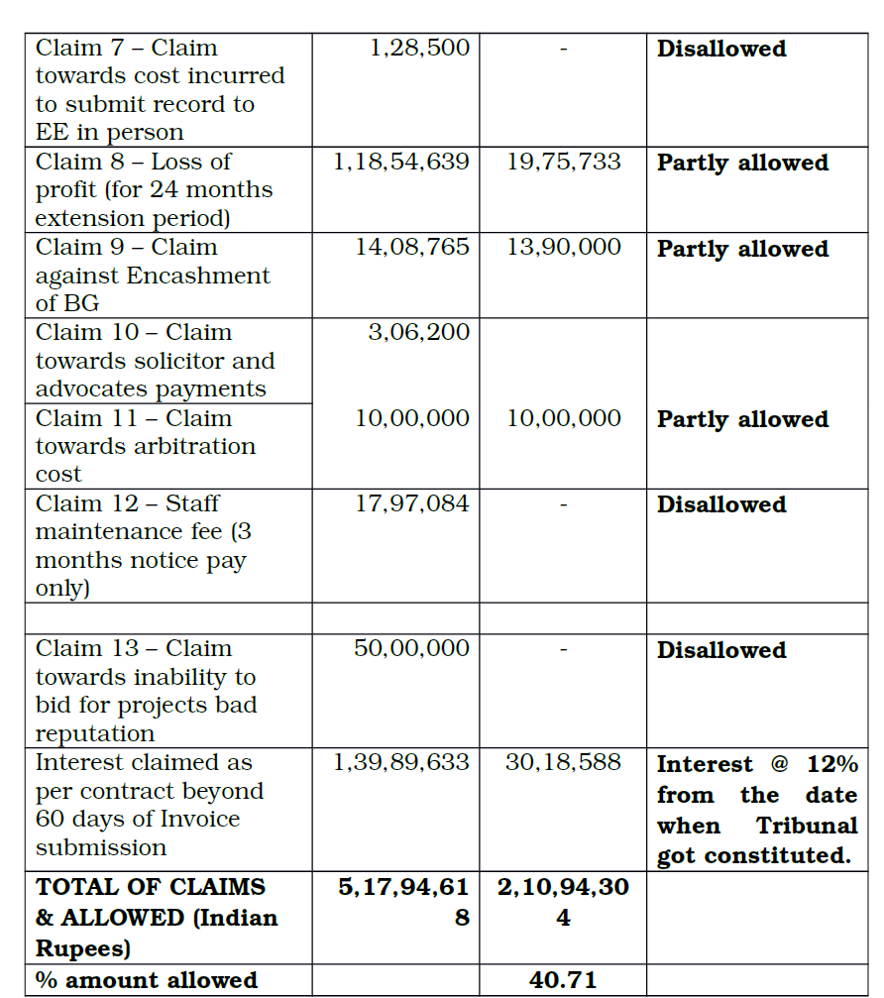

2.3 In view of the finding arrived at by the learned Arbitral Tribunal that the termination of the contract was illegal and without following due procedure as required under the contract and in view of allowing the claims of the claimants partly, the Arbitral Tribunal dismissed the counter claims submitted by the petitioners.

2.4 The award declared by the learned Arbitral Tribunal has been confirmed by the First Appellate Court in a proceeding under Section 34 of the Arbitration Act. The same has been further confirmed by the High Court by the impugned judgment and order in an appeal under Section 37 of the Arbitration Act.
2.5 Feeling aggrieved and dissatisfied with the impugned judgment and order passed by the High Court dismissing the appeal under Section 37 of the Arbitration Act and consequently confirming the award passed by the learned Arbitral Tribunal, the original respondents-State and others have preferred the present special leave petition.

3. Learned counsel appearing on behalf of the petitioners has vehemently submitted that the High Court has materially erred in dismissing the appeal under Section 37 of the Arbitration Act and has materially erred in not properly appreciating the fact that the arbitral award was passed contrary to the materials on record.

3.1 It is vehemently submitted by the learned counsel appearing on behalf of the petitioners that the High Court has materially erred in not properly considering that the suspension under the agreement was not the suspension of work per se, rather was suspension of all payments to the consultants and therefore there was no question of dilution/go-bye of the suspension letter. It is further submitted by the learned counsel appearing on behalf of the petitioners that the High Court has not properly appreciated/considered the scheme of the contract. It is submitted that in case of non-performance of the contract satisfactorily, the first step was suspension of payment and if the failure in performance is not remedied, then the consequence which follows is the next step that being notice of termination by issuing 30 days’ notice. It is submitted that suspension is either operative or revoked by resuming the payments, for, suspension is suspension of payment and not suspension of work/contract. It is submitted that therefore the High Court has materially erred in confirming the findings recorded by the learned Arbitral Tribunal that the termination of the contract was illegal and without following due procedure as required under the contract.

4. While opposing the present special leave petition, learned counsel appearing on behalf of the respondents-original claimants has vehemently submitted that, as such, there are concurrent findings of fact recorded by all the Courts below on the illegal termination of the contract. It is submitted that, on appreciation of evidence, the learned Arbitral Tribunal (in paragraphs 17 to 36) gave the specific findings by giving cogent reasons that the termination of the contract was illegal and without following due procedure as required under the contract. It is submitted that once the findings recorded by the learned Arbitral Tribunal are on appreciation of evidence and considering the materials on record, the same is rightly not interfered with by the Courts below in the proceedings under Sections 34 and 37 of the Arbitration Act.

4.1 Making the above submissions and relying upon the decisions of this Court in the cases of Associate Builders v. DDA¹, NHAI v. Progressive-MVR² and Maharashtra State Electricity Distribution Co. Ltd. v. Datar Switchgear Ltd³., it is prayed to dismiss the present special leave petition.

5. Heard learned counsel appearing on behalf of the respective parties at length.

6. The main controversy is with respect to the termination of the contract vide letter/communication dated 09.2.2012 terminating the contract with effect from 12.03.2012 invoking Clause 2.9.1(1) and (d) of the GCC. That, on appreciation of evidence and considering the various clauses of the contract, the learned Arbitral Tribunal has observed and held by giving cogent reasons that the termination of the contract was illegal and contrary to the terms of the contract and without following due procedure as required under the relevant clauses of the contract. The said finding of fact recorded by the learned Arbitral Tribunal is on appreciation of evidence. The said finding of fact has been confirmed in the proceedings under Sections 34 and 37 of the Arbitration Act. Thus, there are concurrent findings of fact recorded by the learned Arbitral Tribunal, First Appellate Court and the High Court that the termination of the contract was illegal and without following due procedure as required under the relevant provisions of the contract.

6.1 In the case of Progressive-MVR (supra), after considering the catena of decisions of this Court on the scope and ambit of the proceedings under Section 34 of the Arbitration Act, this Court has observed and held that even when the view taken by the arbitrator is a plausible view, and/or when two views are possible, a particular view taken by the Arbitral Tribunal which is also reasonable should not be interfered with in a proceeding under Section 34 of the Arbitration Act.

6.2 In the case of Datar Switchgear Ltd. (supra), this Court has observed and held that the Arbitral Tribunal is the master of evidence and the findings of fact which are arrived at by the arbitrators on the basis of the evidence on record are not to be scrutinized as if the Court was sitting in appeal. In para 51 of the judgment, it is observed and held as under:

51 Categorical findings are arrived at by the Arbitral Tribunal to the effect that insofar as Respondent 2 is concerned, it was always ready and willing to perform its contractual obligations, but was prevented by the appellant from such performance. Another specific finding which is returned by the Arbitral Tribunal is that the appellant had not given the list of locations and, therefore, its submission that Respondent 2 had adequate lists of locations available but still failed to install the contract objects was not acceptable. In fact, on this count, the Arbitral Tribunal has commented upon the working of the appellant itself and expressed its dismay about lack of control by the Head Office of the appellant over the field offices which led to the failure of the contract. These are findings of facts which are arrived at by the Arbitral Tribunal after appreciating the evidence and documents on record. From these findings it stands established that there is a fundamental breach on the part of the appellant in carrying out its obligations, with no fault of Respondent 2 which had invested whopping amount of Rs 163 crores in the project. A perusal of the award reveals that the Tribunal investigated the conduct of the entire transaction between the parties pertaining to the work order, including withholding of DTC locations, allegations and counter-allegations by the parties concerning installed objects. The arbitrators did not focus on a particular breach qua particular number of objects/class of objects. Respondent 2 is right in its submission that the fundamental breach, by its very nature, pervades the entire contract and once committed, the contract as a whole stands abrogated. It is on the aforesaid basis that the Arbitral Tribunal has come to the conclusion that the termination of contract by Respondent 2 was in order and valid. The proposition of law that the Arbitral Tribunal is the master of evidence and the findings of fact which are arrived at by the arbitrators on the basis of evidence on record are not to be scrutinised as if the Court was sitting in appeal now stands settled by a catena of judgments pronounced by this Court without any exception thereto [ See — Associate Builders v. DDA⁴, and S. Munishamappa v. B. Venkatarayappa⁵,. As held by this Court in catena of decisions, the award passed by the Arbitral Tribunal can be interfered with in the proceedings under Sections 34 and 37 of Arbitration Act only in a case where the finding is perverse and/or contrary to the evidence and/or the same is against the public policy. (see Associate Builders v. DDA⁶ etc.)

6.3 In the present case, the categorical findings arrived at by the Arbitral Tribunal are to the effect that the termination of the contract was illegal and without following due procedure of the provisions of the contract. The findings are on appreciation of evidence considering the relevant provisions and material on record as well as on interpretation of the relevant provisions of the contract, which are neither perverse nor contrary to the evidence in record. Therefore, as such, the First Appellate Court and the High Court have rightly not interfered with such findings of fact recorded by the learned Arbitral Tribunal.

6.4 Once it is held that the termination was illegal and thereafter when the learned Arbitral Tribunal has considered the claims on merits, which basically were with respect to the unpaid amount in respect of the work executed under the contract and loss of profit. Cogent reasons have been given by the learned Arbitral Tribunal while allowing/partly allowing the respective claims. It is required to be noted that the learned Arbitral Tribunal has partly allowed some of the claims and even disallowed also some of the claims. There is a proper application of mind by the learned Arbitral Tribunal on the respective claims. Therefore, the same is not required to be interfered with, more particularly, when in the proceedings under Sections 34 and 37 of the Arbitration Act, the petitioners have failed.

7. Once the finding recorded by the learned Arbitral Tribunal that the termination of the contract was illegal is upheld and the claims made by the claimants have been allowed or allowed partly, in that case, the counter-claim submitted by the petitioners was liable to be rejected and the same is rightly rejected. No interference of this Court is called for.

8. In view of the above and for the reasons stated above, the present special leave petition deserves to be dismissed and is accordingly dismissed. However, in the facts and circumstances of the case, there will be no order as to costs.

Judgment Referred.

¹(2015) 3 SCC 0049
²(2018) 14 SCC 0688
³(2018) 3 SCC 0133
⁴(2015) 3 SCC 0049
⁵(1981) 3 SCC 0260
⁶(2015) 3 SCC 0049

